YanXuan NUID:001563047

**Program Structures & Algorithms**

**Fall 2021**

**Assignment No. 5**

* **Task (List down the tasks performed in the Assignment)**

1. **Experiment and come up with a good value for cutoff.**
2. **Decide on an ideal number of separate threads and arrange for that number of partitions to be parallelized.**
3. **Prepare a report that shows the results of experiments and draw a conclusion (or more) about the efficacy of this method of parallelizing sort.**
4. **Analyze and summarize the experimental data, and get the relationship between cutoff numbers, array’s length and the number of threads.**

* **Relationship Conclusion: (For ex : z = a * b)**

1. **The relationship between the best cutoff number, the array’s length and the number of threads is:**
$$the best cutoff number= \frac{arrays.length}{threadNumber}$$

2. **The ParSort always does best (compared by the times the best cutoff numbers cost) when there are 4 threads.**
3. **It is not that the more threads, the faster the ParSort speed.**

* **Evidence to support the conclusion:**

1. **Output (Snapshot of Code output in the terminal)**
   1. **Keep the array’s length and the number of threads unchangeable, search for the best cutoff number.**

**Output when threadNumber = 2 and array’s length = 2,000,000**

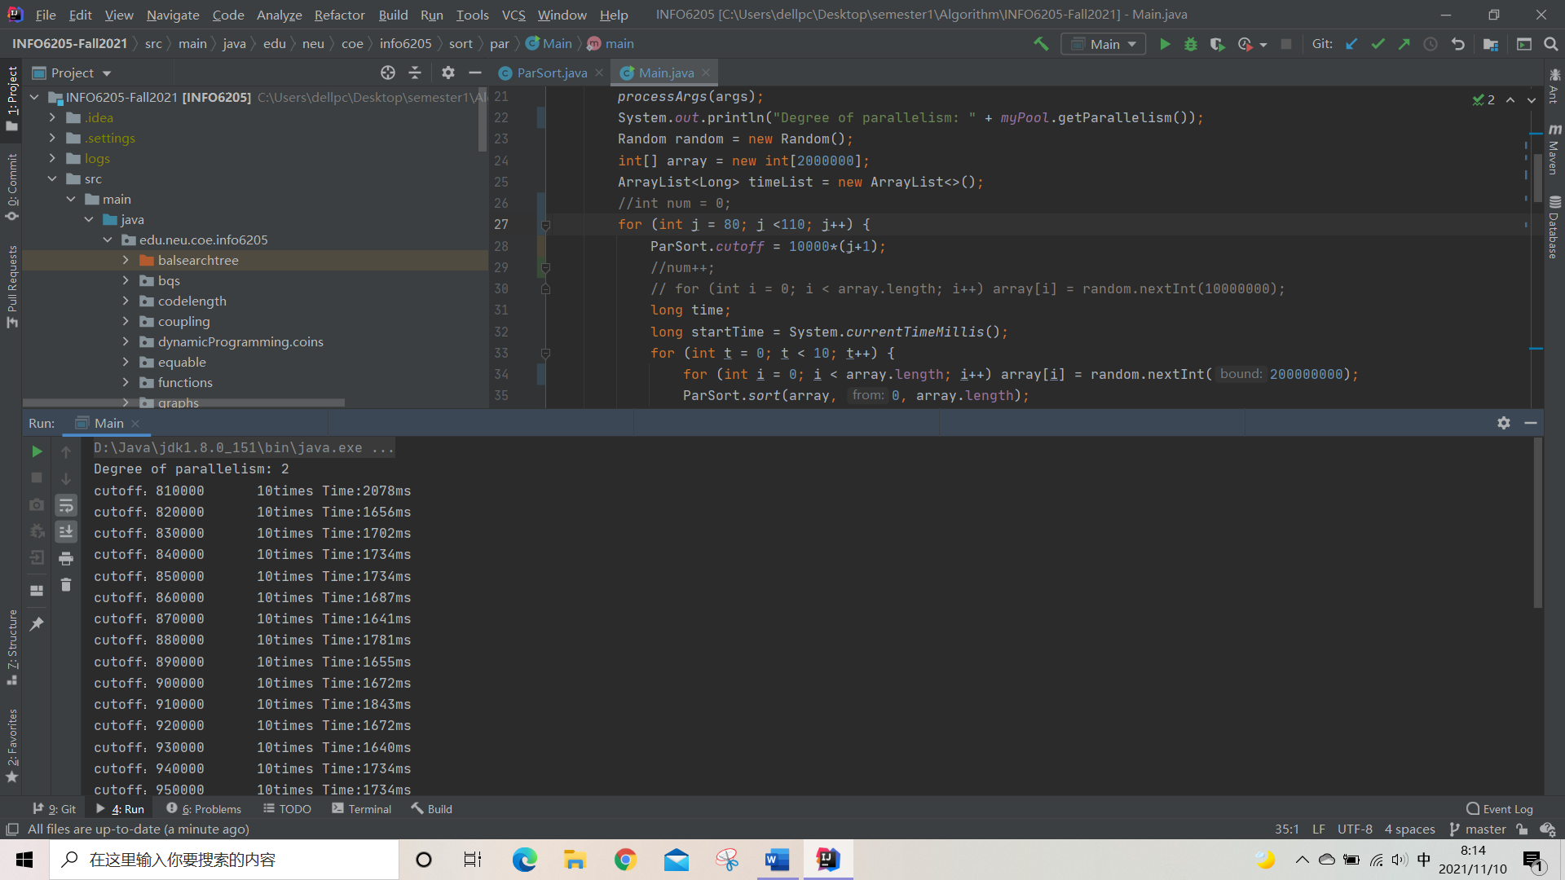

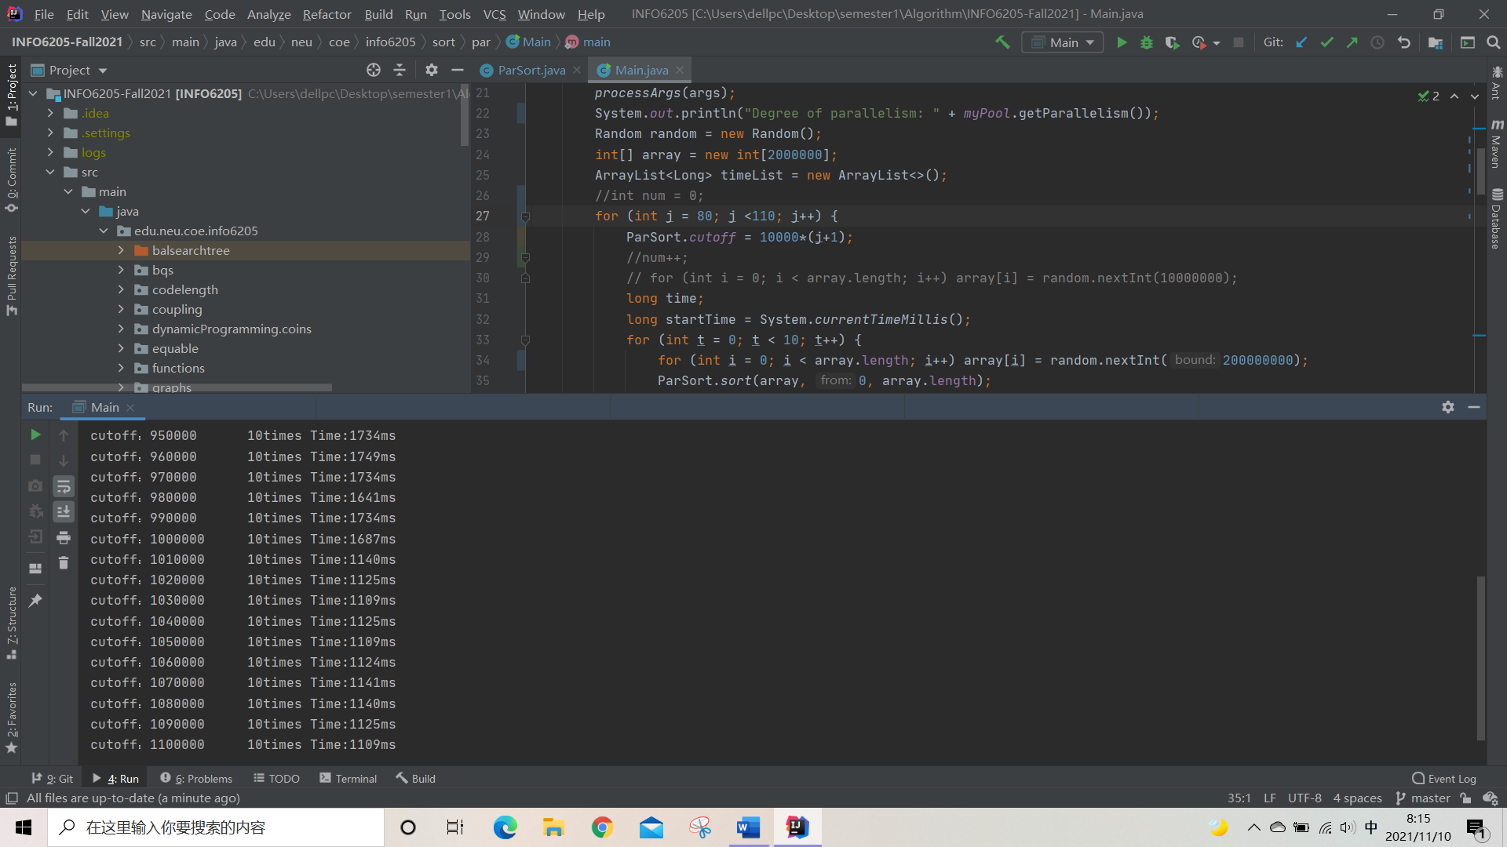

**Output text:**

**Degree of parallelism: 2**

**cutoff：950000 10times Time:1734ms**

**cutoff：960000 10times Time:1749ms**

**cutoff：970000 10times Time:1734ms**

**cutoff：980000 10times Time:1641ms**

**cutoff：990000 10times Time:1734ms**

**cutoff：1000000 10times Time:1687ms**

**cutoff：1010000 10times Time:1140ms**

**cutoff：1020000 10times Time:1125ms**

**cutoff：1030000 10times Time:1109ms**

**cutoff：1040000 10times Time:1125ms**

**cutoff：1050000 10times Time:1109ms**

**It seems that when the cutoff number is 1,010,000, the time significantly shortened, compared to the cutoff number is 1,000,000.**

**At which time, $\frac{arrays.length}{threadNumber}= \frac{2000000}{2}=1,000,000$.**

**Simulation:**



**It seems that if the cutoff number is bigger than 1,000,000, which is equals to $\frac{arrays.length}{threadNumber}$, the 10times Time drops a lot.**

* 1. **Keep the array’s length unchangeable, change the number of threads, search for the best cutoff number.**

**(1)Output when threadNumber = 4 and array’s length = 2,000,000**

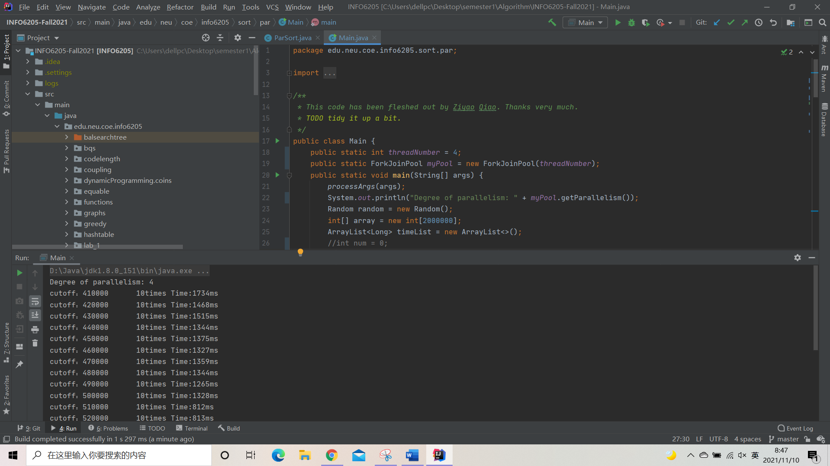

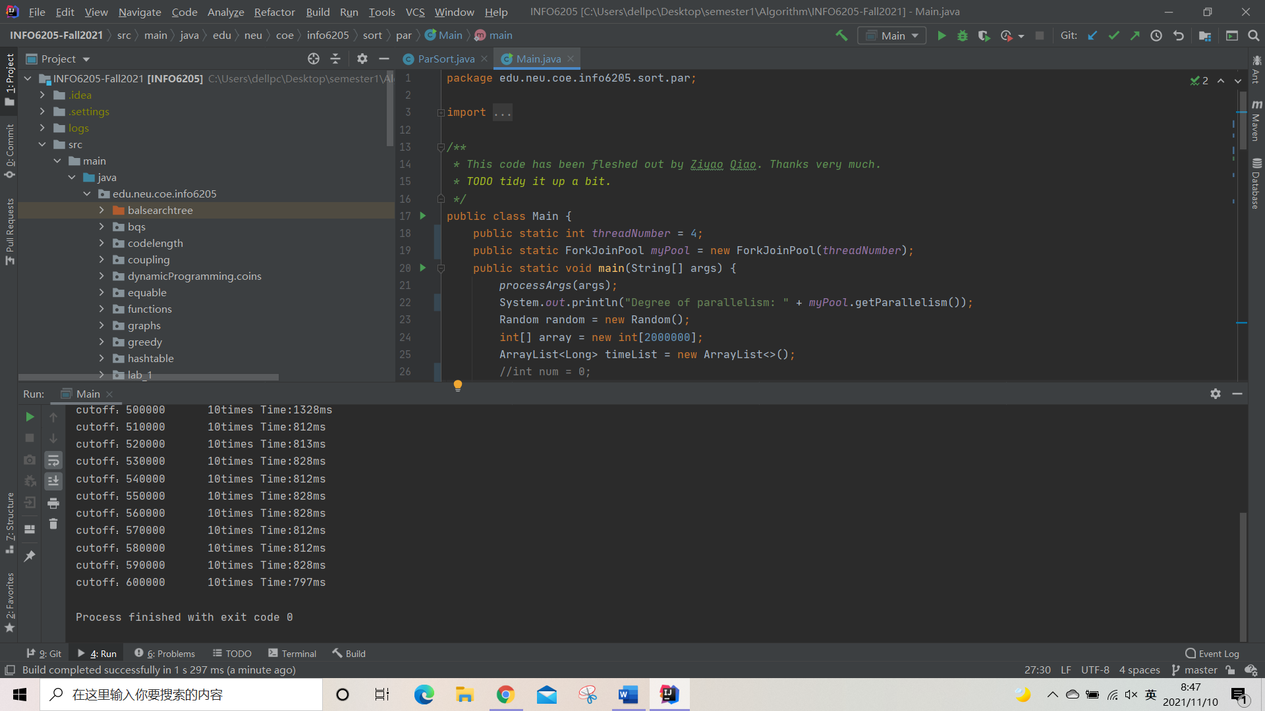

**Output text:**

**Degree of parallelism: 4**

**cutoff：450000 10times Time:1375ms**

**cutoff：460000 10times Time:1327ms**

**cutoff：470000 10times Time:1359ms**

**cutoff：480000 10times Time:1344ms**

**cutoff：490000 10times Time:1265ms**

**cutoff：500000 10times Time:1328ms**

**cutoff：510000 10times Time:812ms**

**cutoff：520000 10times Time:813ms**

**cutoff：530000 10times Time:828ms**

**cutoff：540000 10times Time:812ms**

**cutoff：550000 10times Time:828ms**

We could find that in this case, time drops a lot after the cutoff is more than 500,000.

At which time, $\frac{arrays.length}{threadNumber}= \frac{2000000}{4}=500,000$.

**(2)Output when threadNumber = 8 and array’s length = 2,000,000**

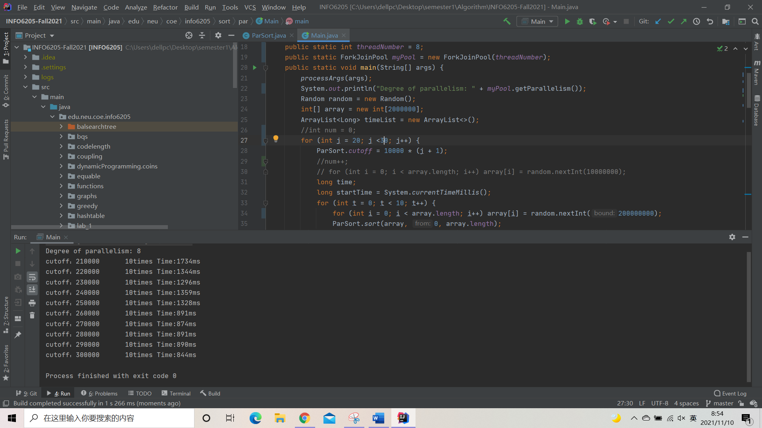

**Output text:**

**Degree of parallelism: 8**

**cutoff：210000 10times Time:1734ms**

**cutoff：220000 10times Time:1344ms**

**cutoff：230000 10times Time:1296ms**

**cutoff：240000 10times Time:1359ms**

**cutoff：250000 10times Time:1328ms**

**cutoff：260000 10times Time:891ms**

**cutoff：270000 10times Time:874ms**

**cutoff：280000 10times Time:891ms**

**cutoff：290000 10times Time:890ms**

**cutoff：300000 10times Time:844ms**

We could find that in this case, time drops a lot after the cutoff is more than 250,000.

At which time, $\frac{arrays.length}{threadNumber}= \frac{2000000}{8}=250,000$.

**(3)Output when threadNumber = 16 and array’s length = 2,000,000**

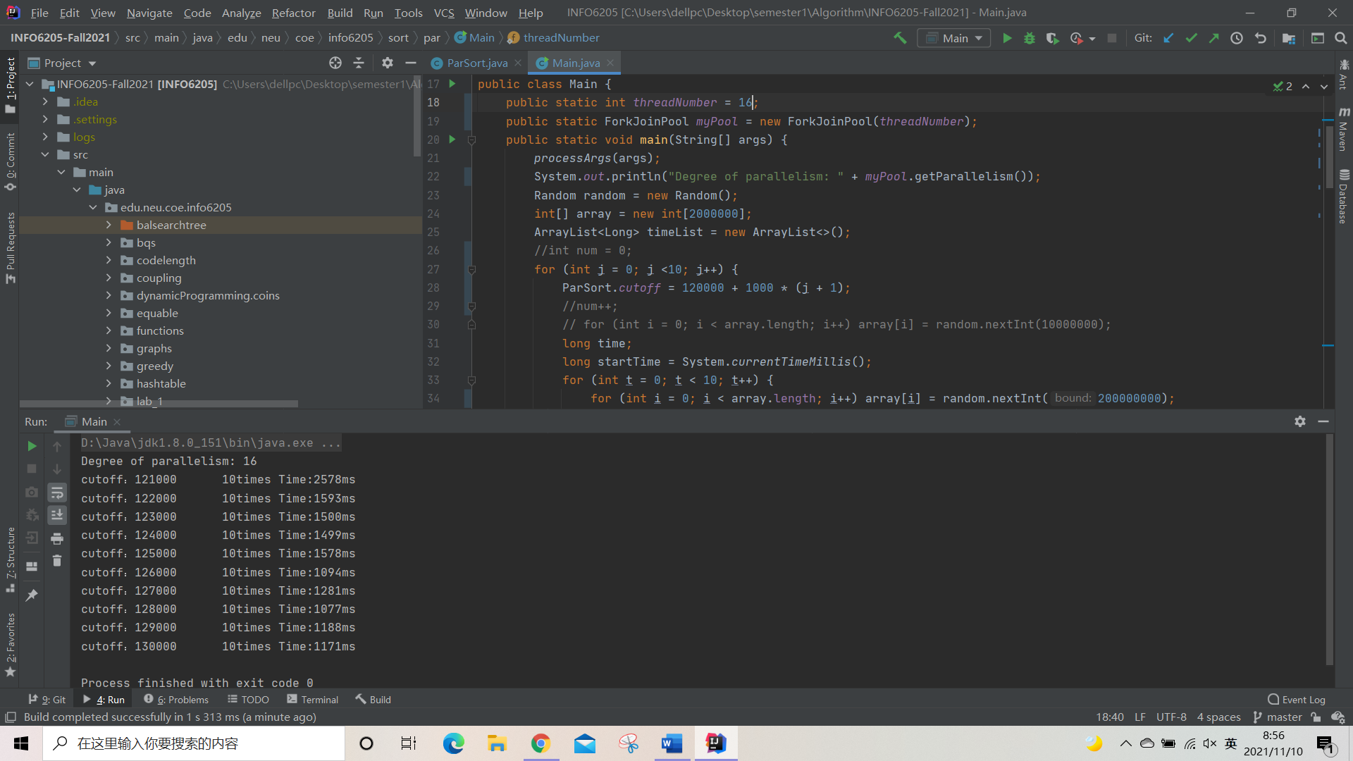

**Output text:**

**Degree of parallelism: 16**

**cutoff：121000 10times Time:2578ms**

**cutoff：122000 10times Time:1593ms**

**cutoff：123000 10times Time:1500ms**

**cutoff：124000 10times Time:1499ms**

**cutoff：125000 10times Time:1578ms**

**cutoff：126000 10times Time:1094ms**

**cutoff：127000 10times Time:1281ms**

**cutoff：128000 10times Time:1077ms**

**cutoff：129000 10times Time:1188ms**

**cutoff：130000 10times Time:1171ms**

We could find that in this case, time drops a lot after the cutoff is more than 125,000.

At which time, $\frac{arrays.length}{threadNumber}= \frac{2000000}{16}=125,000$.

**(4)Output when threadNumber = 32 and array’s length = 2,000,000**

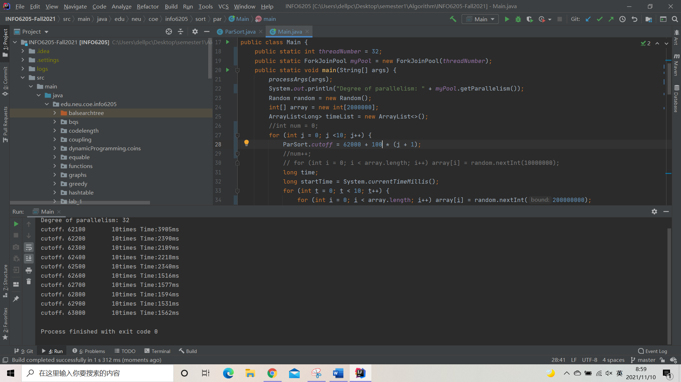

**Output text:**

**Degree of parallelism: 32**

**cutoff：62100 10times Time:3905ms**

**cutoff：62200 10times Time:2390ms**

**cutoff：62300 10times Time:2109ms**

**cutoff：62400 10times Time:2218ms**

**cutoff：62500 10times Time:2340ms**

**cutoff：62600 10times Time:1516ms**

**cutoff：62700 10times Time:1577ms**

**cutoff：62800 10times Time:1594ms**

**cutoff：62900 10times Time:1531ms**

**cutoff：63000 10times Time:1562ms**

We could find that in this case, time drops a lot after the cutoff is more than 62,500.

At which time, $\frac{arrays.length}{threadNumber}= \frac{2000000}{32}=62,500$.

**(5)Output when threadNumber = 64 and array’s length = 2,000,000**

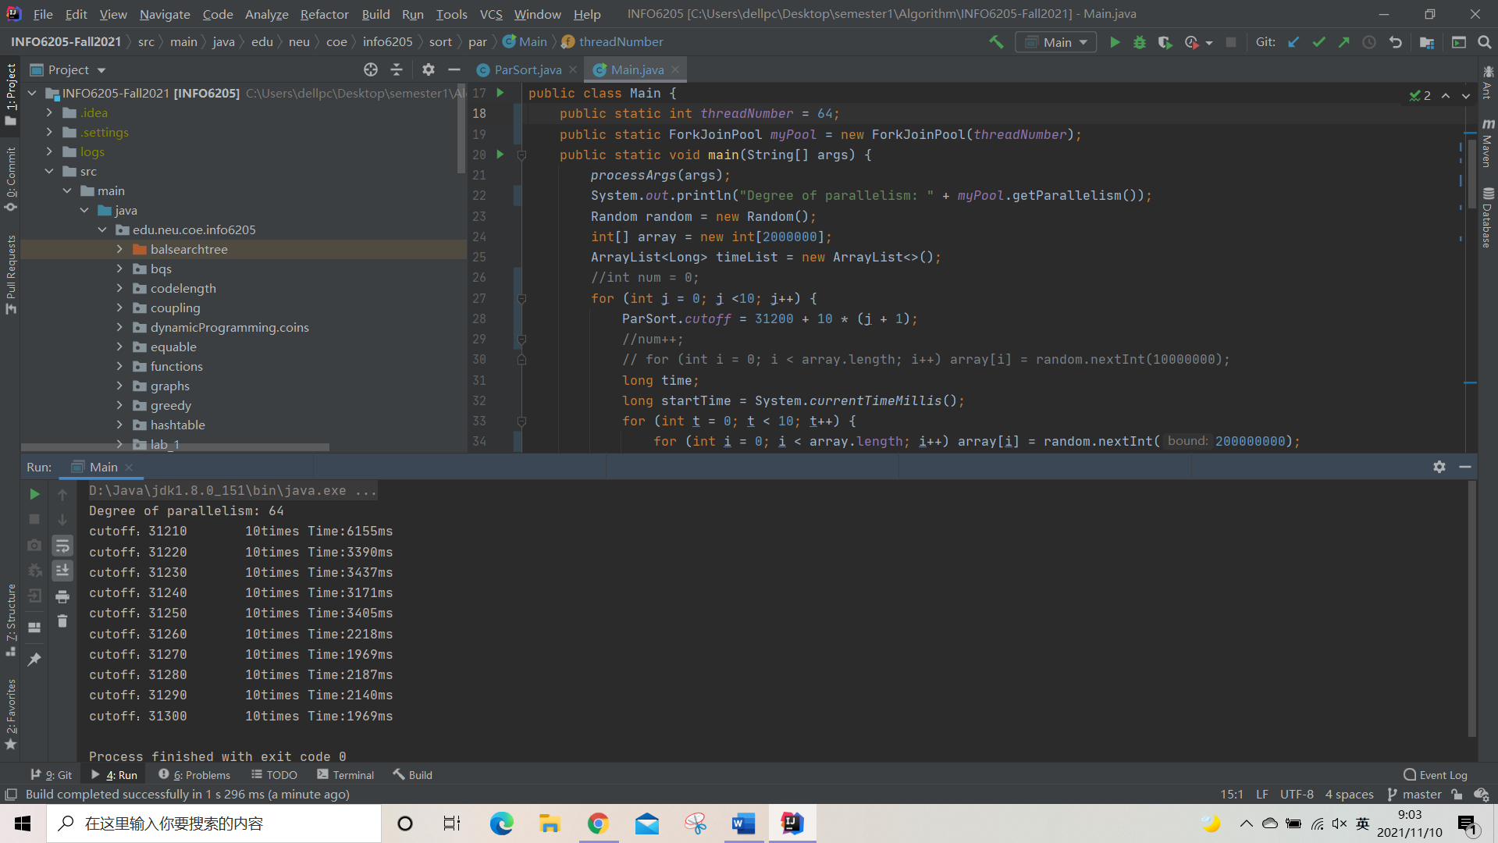

**Output text:**

**Degree of parallelism: 64**

**cutoff：31210 10times Time:6155ms**

**cutoff：31220 10times Time:3390ms**

**cutoff：31230 10times Time:3437ms**

**cutoff：31240 10times Time:3171ms**

**cutoff：31250 10times Time:3405ms**

**cutoff：31260 10times Time:2218ms**

**cutoff：31270 10times Time:1969ms**

**cutoff：31280 10times Time:2187ms**

**cutoff：31290 10times Time:2140ms**

**cutoff：31300 10times Time:1969ms**

We could find that in this case, time drops a lot after the cutoff is more than 31,250.

At which time, $\frac{arrays.length}{threadNumber}= \frac{2000000}{64}=31,250$.

**(6)Output when threadNumber = 128 and array’s length = 2,000,000**

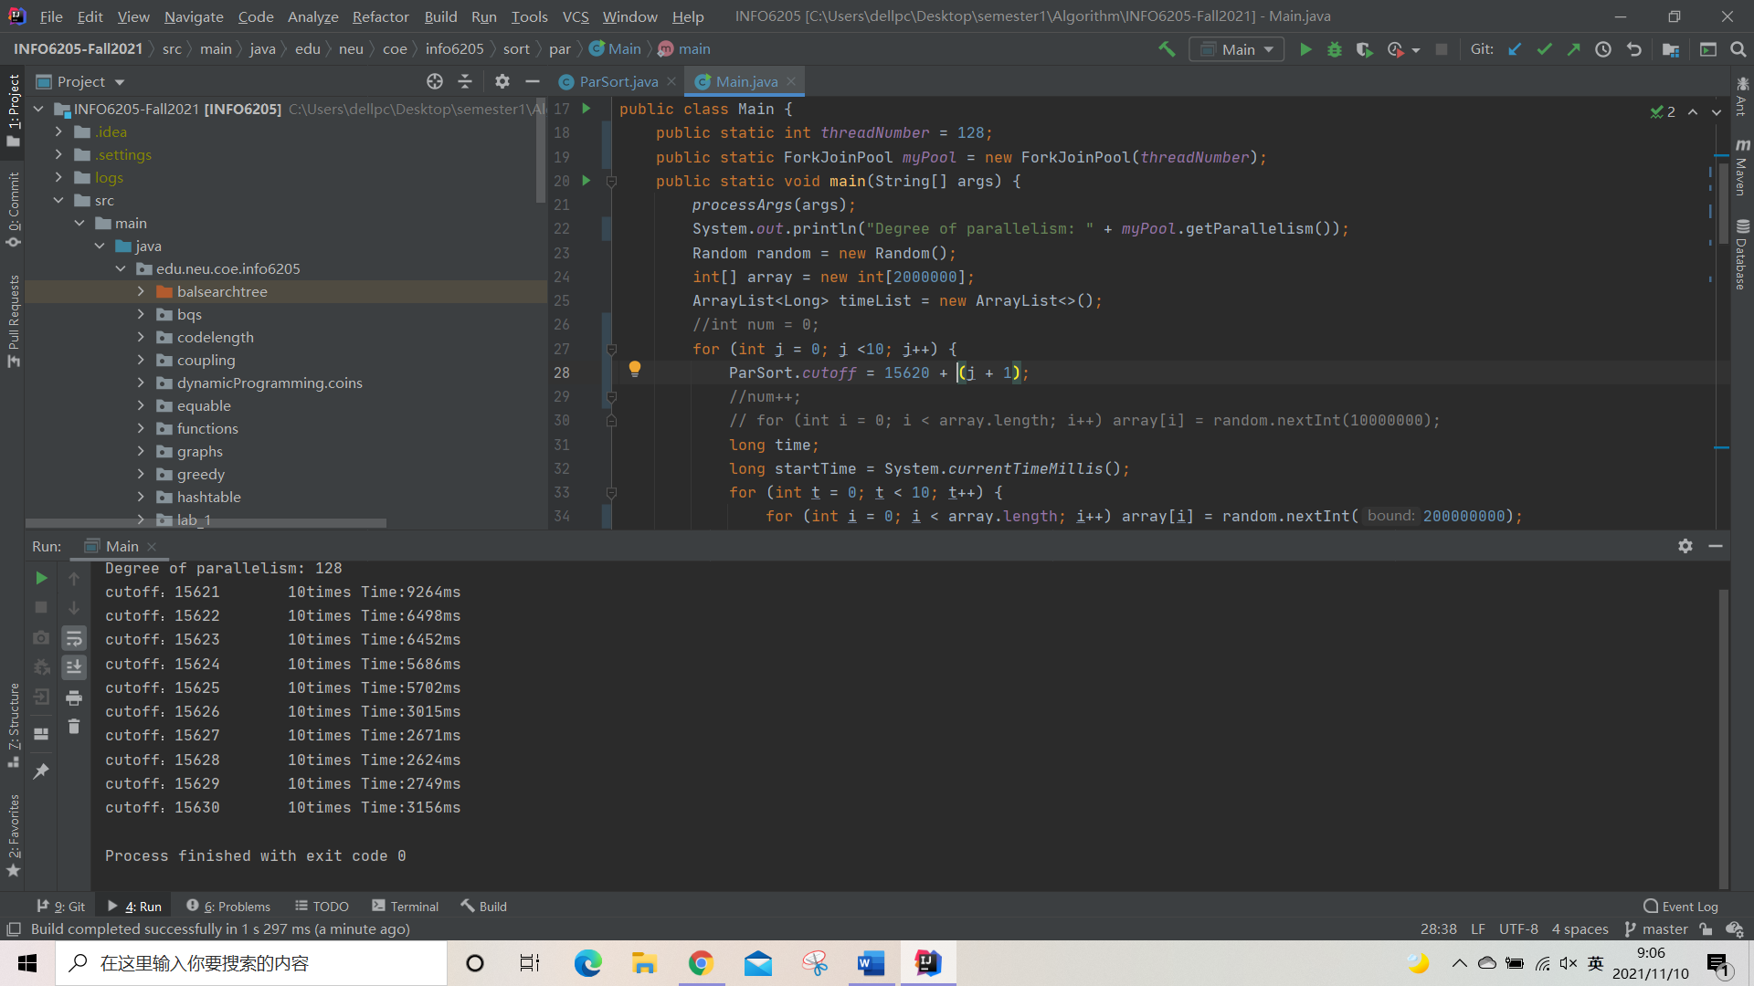

**Output text:**

**Degree of parallelism: 128**

**cutoff：15621 10times Time:9264ms**

**cutoff：15622 10times Time:6498ms**

**cutoff：15623 10times Time:6452ms**

**cutoff：15624 10times Time:5686ms**

**cutoff：15625 10times Time:5702ms**

**cutoff：15626 10times Time:3015ms**

**cutoff：15627 10times Time:2671ms**

**cutoff：15628 10times Time:2624ms**

**cutoff：15629 10times Time:2749ms**

**cutoff：15630 10times Time:3156ms**

We could find that in this case, time drops a lot after the cutoff is more than 15,625.

At which time, $\frac{arrays.length}{threadNumber}= \frac{2000000}{128}=15,625$.

**(7)Output when threadNumber = 256 and array’s length = 2,000,000**

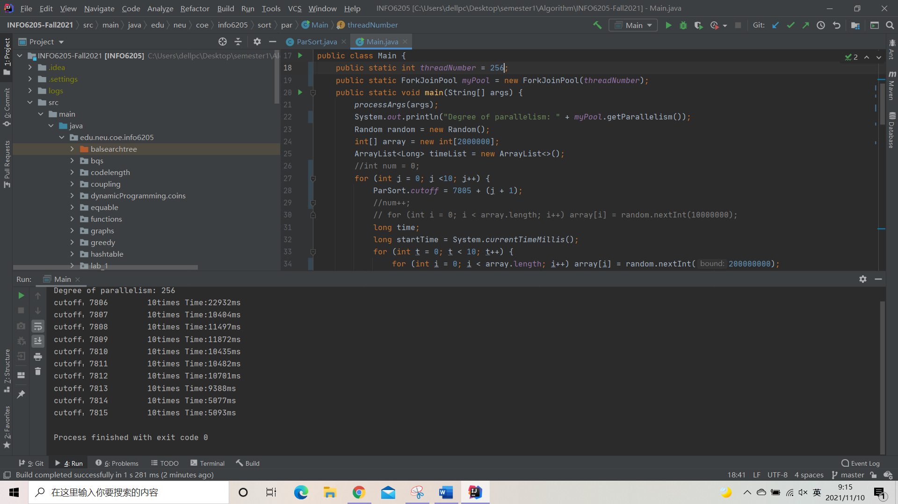

**Output text:**

**Degree of parallelism: 256**

**cutoff：7806 10times Time:22932ms**

**cutoff：7807 10times Time:10404ms**

**cutoff：7808 10times Time:11497ms**

**cutoff：7809 10times Time:11872ms**

**cutoff：7810 10times Time:10435ms**

**cutoff：7811 10times Time:10482ms**

**cutoff：7812 10times Time:10701ms**

**cutoff：7813 10times Time:9388ms**

**cutoff：7814 10times Time:5077ms**

**cutoff：7815 10times Time:5093ms**

We could find that in this case, time drops a lot after the cutoff is more than 7,813.

At which time, $\frac{arrays.length}{threadNumber}= \frac{2000000}{256}=7,812.5$.

The simulation between the thread number and the best cutoff number when array’s length is unchangeable is showed below.



**It shows that y-axis is inversely proportional to x, which means with the growth of the thread numbers, the best cutoffs decrease. So in the function to get the best cutoff number, the thread number should be in the position of the denominator.**



**We can also make a conclusion that, though each thread number has its’ own best cutoff number, the best cutoffs’ time costs are different. In this simulation, we could find that when the thread number is 4, and the array’s length is 2,000,000, it takes least time in the ParSort. In other words, the ParSort does best when there are 4 threads when the array’s length is unchangeable.**

**To test if the thread number is 4 is best fits the ParSort, we could also make tests to test it. Because the steps are same as the above, I just give out the data and simulation directly.**

**When the array’s length = 4,000,000**



**When the array’s length = 8,000,000**



**When the array’s length = 16,000,000**



**We could see that even the length of the array changes, the best cutoff numbers always cost the least time when the thread number is 4, which confirms the previous conclusion, that the ParSort does best when there are 4 threads when the array’s length is unchangeable.**

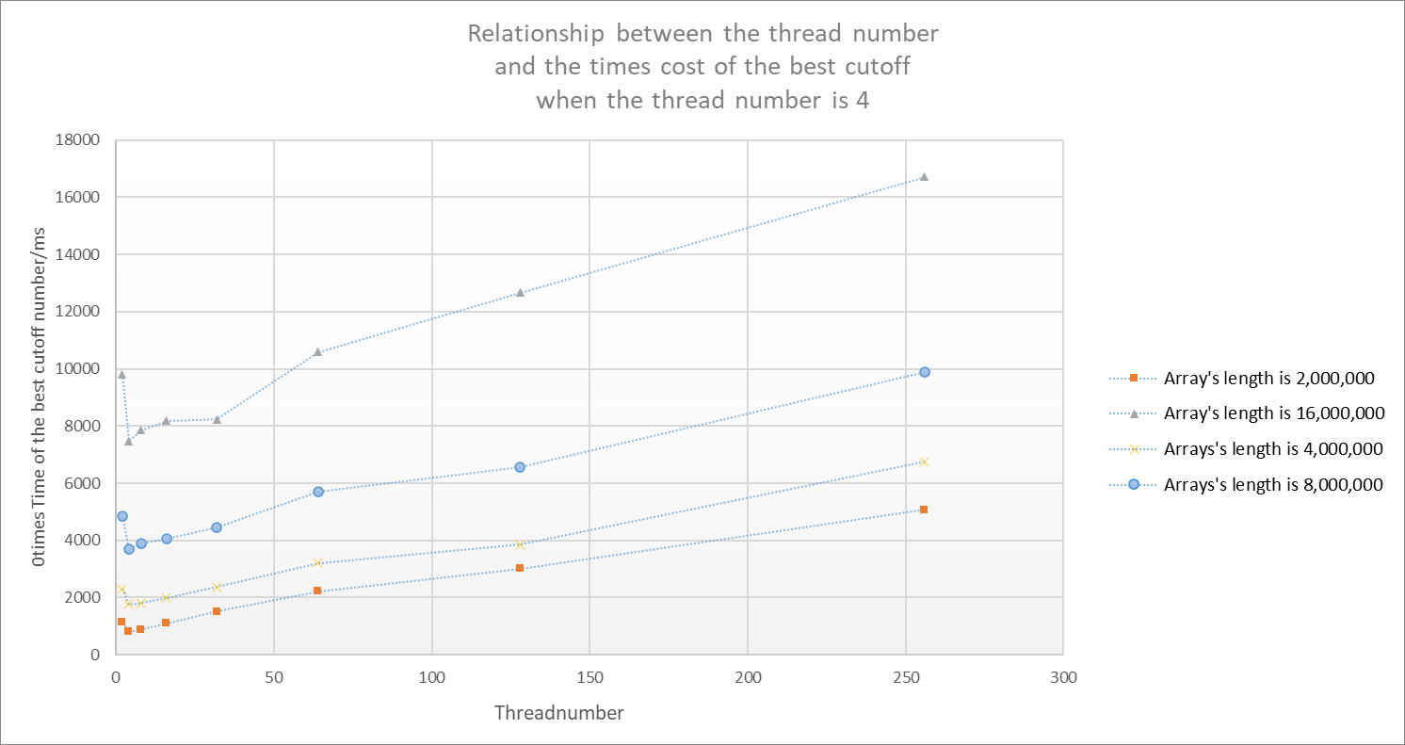

**We could also find in the above diagram that the time costs of the best cutoff numbers increase with the number of threads when the number of threads is not 4, which means the increase of thread numbers doesn’t improve the ParSort’s performance. Why it happens? Personally, I think the main reason is, if multiple threads operate on the same atomic data synchronously, the resource may also be occupied easily.**

* 1. **Keep the number of threads unchangeable, change the array’s length, search for the best cutoff number**
     1. **Output when threadNumber = 4 and array’s length = 1,000,000**

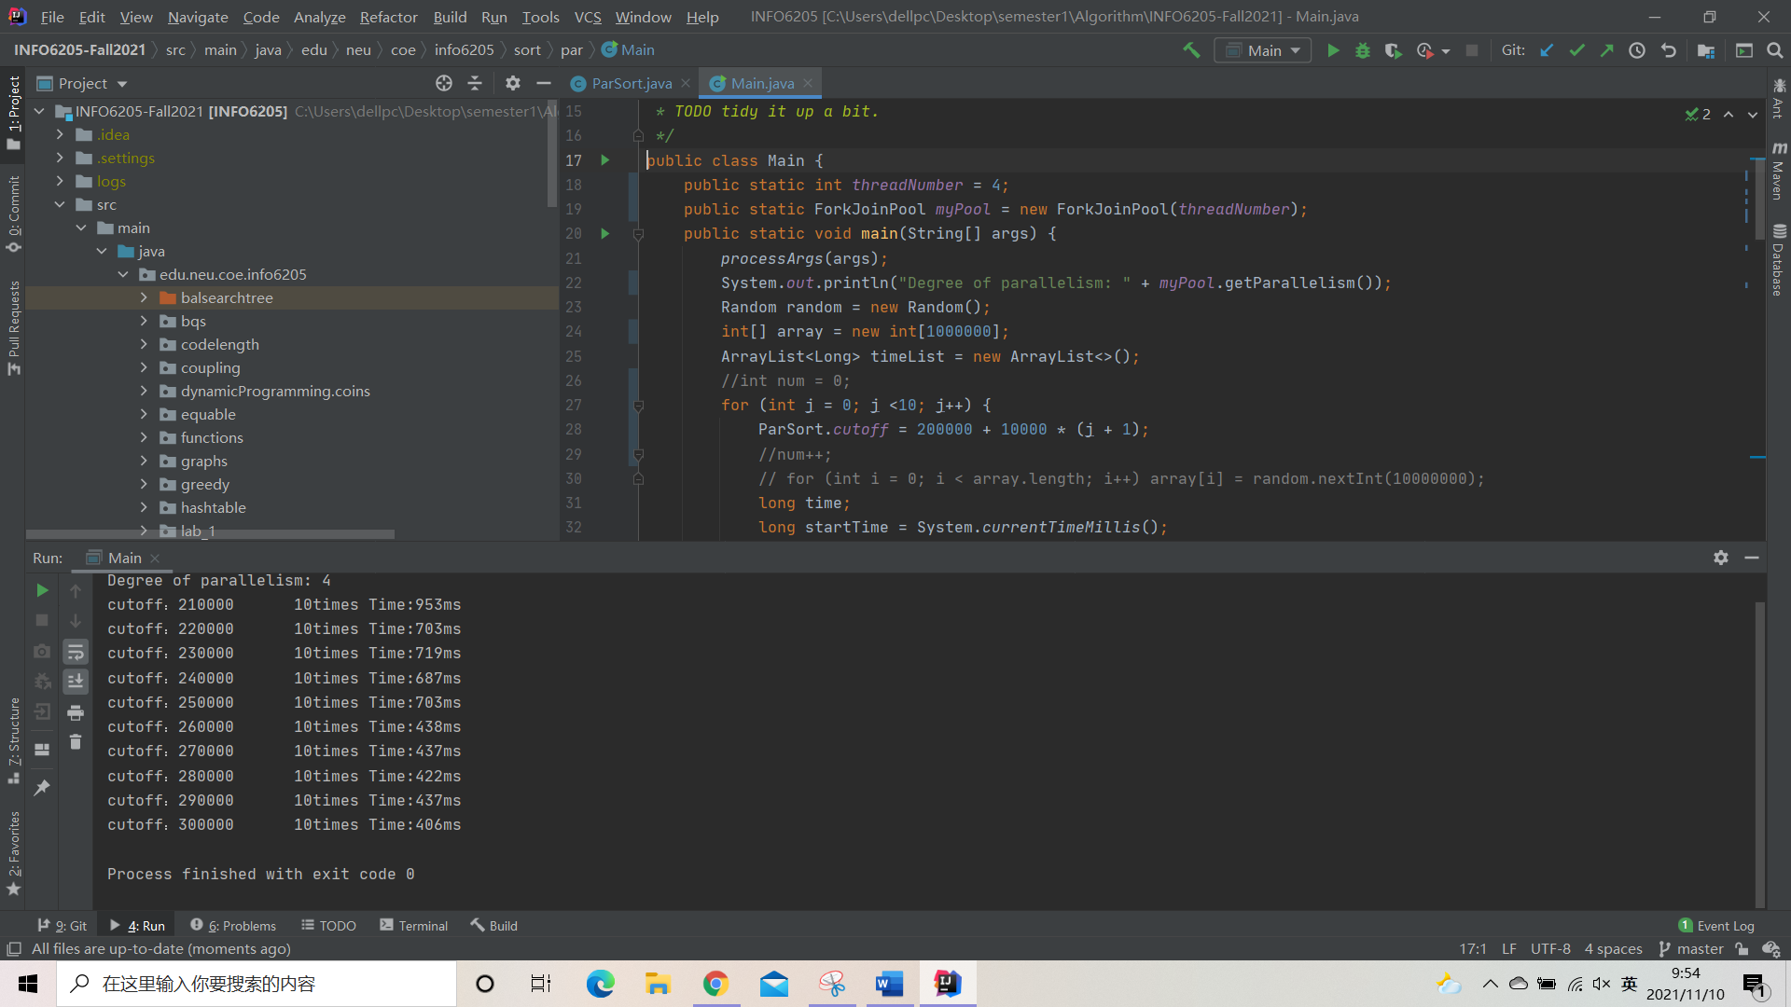

**Output text:**

**Degree of parallelism: 4**

**cutoff：210000 10times Time:953ms**

**cutoff：220000 10times Time:703ms**

**cutoff：230000 10times Time:719ms**

**cutoff：240000 10times Time:687ms**

**cutoff：250000 10times Time:703ms**

**cutoff：260000 10times Time:438ms**

**cutoff：270000 10times Time:437ms**

**cutoff：280000 10times Time:422ms**

**cutoff：290000 10times Time:437ms**

**cutoff：300000 10times Time:406ms**

We could find that in this case, time drops a lot after the cutoff is more than 250,000.

At which time, $\frac{arrays.length}{threadNumber}= \frac{1000000}{4}=250,000$.

**(2)Output when threadNumber = 4 and array’s length = 2,000,000**





**Output text:**

**Degree of parallelism: 4**

**cutoff：450000 10times Time:1375ms**

**cutoff：460000 10times Time:1327ms**

**cutoff：470000 10times Time:1359ms**

**cutoff：480000 10times Time:1344ms**

**cutoff：490000 10times Time:1265ms**

**cutoff：500000 10times Time:1328ms**

**cutoff：510000 10times Time:812ms**

**cutoff：520000 10times Time:813ms**

**cutoff：530000 10times Time:828ms**

**cutoff：540000 10times Time:812ms**

**cutoff：550000 10times Time:828ms**

We could find that in this case, time drops a lot after the cutoff is more than 500,000.

At which time, $\frac{arrays.length}{threadNumber}= \frac{2000000}{4}=500,000$.

**(3)Output when threadNumber = 4 and array’s length = 4,000,000**

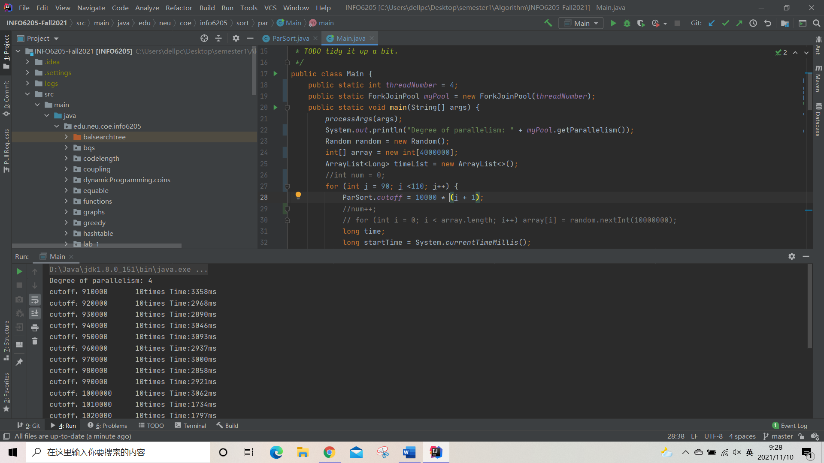

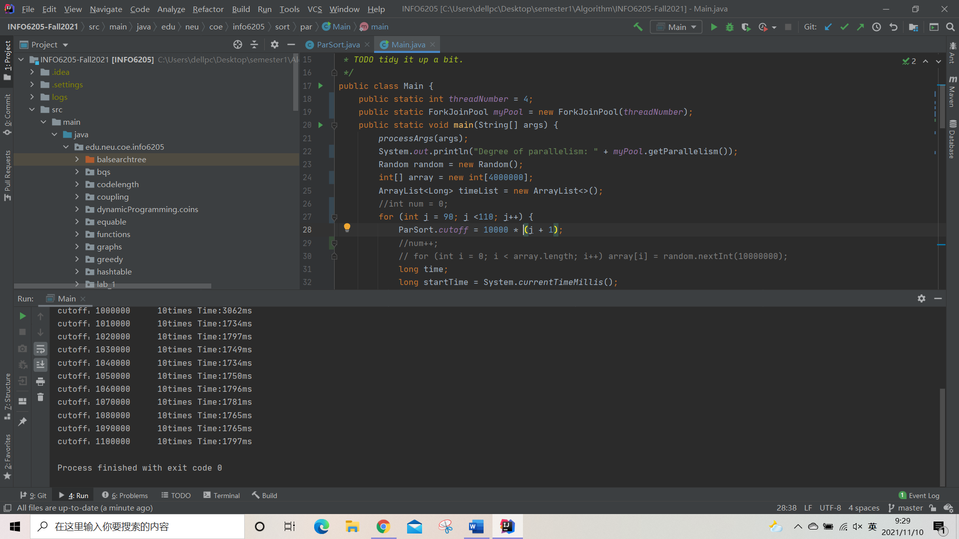

**Output text:**

**Degree of parallelism: 4**

**cutoff：910000 10times Time:3358ms**

**cutoff：920000 10times Time:2968ms**

**cutoff：930000 10times Time:2890ms**

**cutoff：940000 10times Time:3046ms**

**cutoff：950000 10times Time:3093ms**

**cutoff：960000 10times Time:2937ms**

**cutoff：970000 10times Time:3000ms**

**cutoff：980000 10times Time:2858ms**

**cutoff：990000 10times Time:2921ms**

**cutoff：1000000 10times Time:3062ms**

**cutoff：1010000 10times Time:1734ms**

**cutoff：1020000 10times Time:1797ms**

**cutoff：1030000 10times Time:1749ms**

**cutoff：1040000 10times Time:1734ms**

**cutoff：1050000 10times Time:1750ms**

**cutoff：1060000 10times Time:1796ms**

**cutoff：1070000 10times Time:1781ms**

**cutoff：1080000 10times Time:1765ms**

**cutoff：1090000 10times Time:1765ms**

**cutoff：1100000 10times Time:1797ms**

We could find that in this case, time drops a lot after the cutoff is more than 1,000,000.

At which time, $\frac{arrays.length}{threadNumber}= \frac{4000000}{4}=1,000,000$.

**(4)Output when threadNumber = 4 and array’s length = 8,000,000**

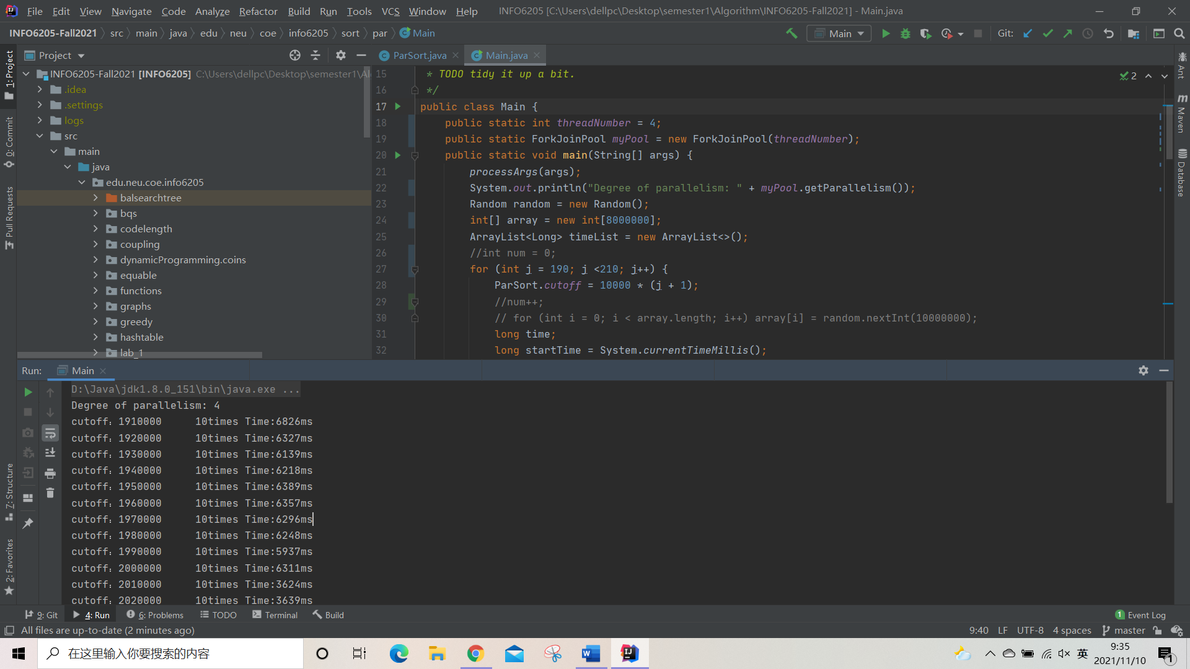

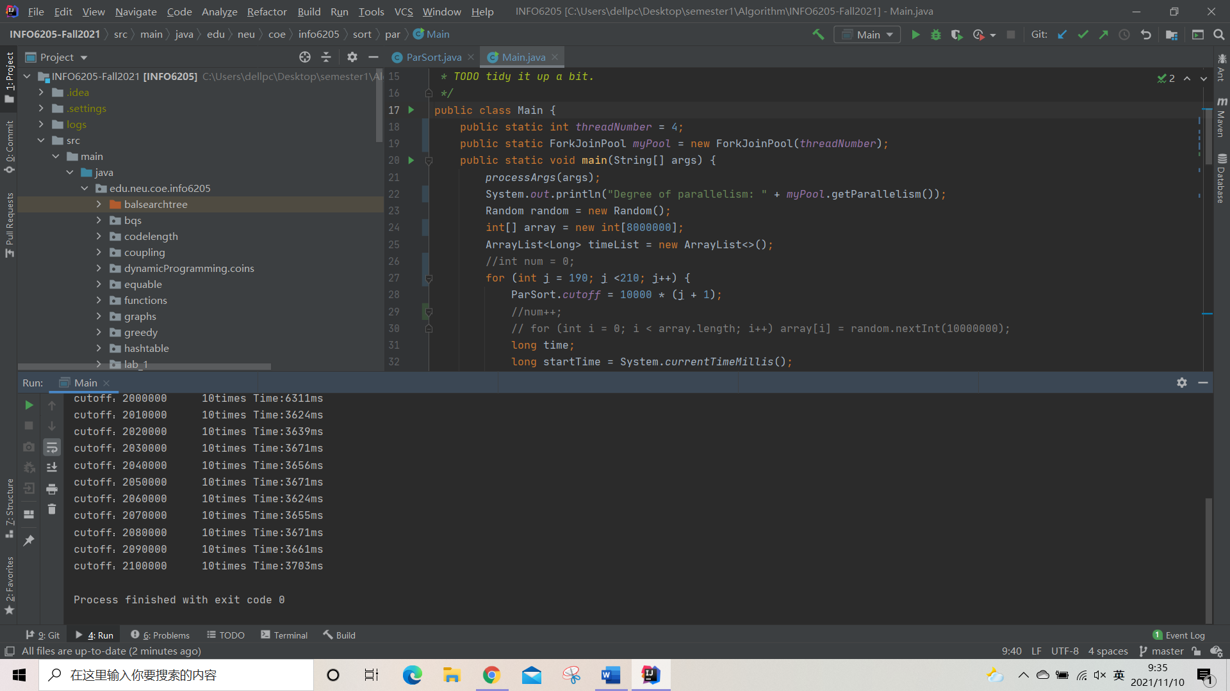

**Output text:**

**Degree of parallelism: 4**

**cutoff：1950000 10times Time:6389ms**

**cutoff：1960000 10times Time:6357ms**

**cutoff：1970000 10times Time:6296ms**

**cutoff：1980000 10times Time:6248ms**

**cutoff：1990000 10times Time:5937ms**

**cutoff：2000000 10times Time:6311ms**

**cutoff：2010000 10times Time:3624ms**

**cutoff：2020000 10times Time:3639ms**

**cutoff：2030000 10times Time:3671ms**

**cutoff：2040000 10times Time:3656ms**

**cutoff：2050000 10times Time:3671ms**

We could find that in this case, time drops a lot after the cutoff is more than 2,000,000.

At which time, $\frac{arrays.length}{threadNumber}= \frac{8000000}{4}=2,000,000$.

**(5)Output when threadNumber = 4 and array’s length = 16,000,000**

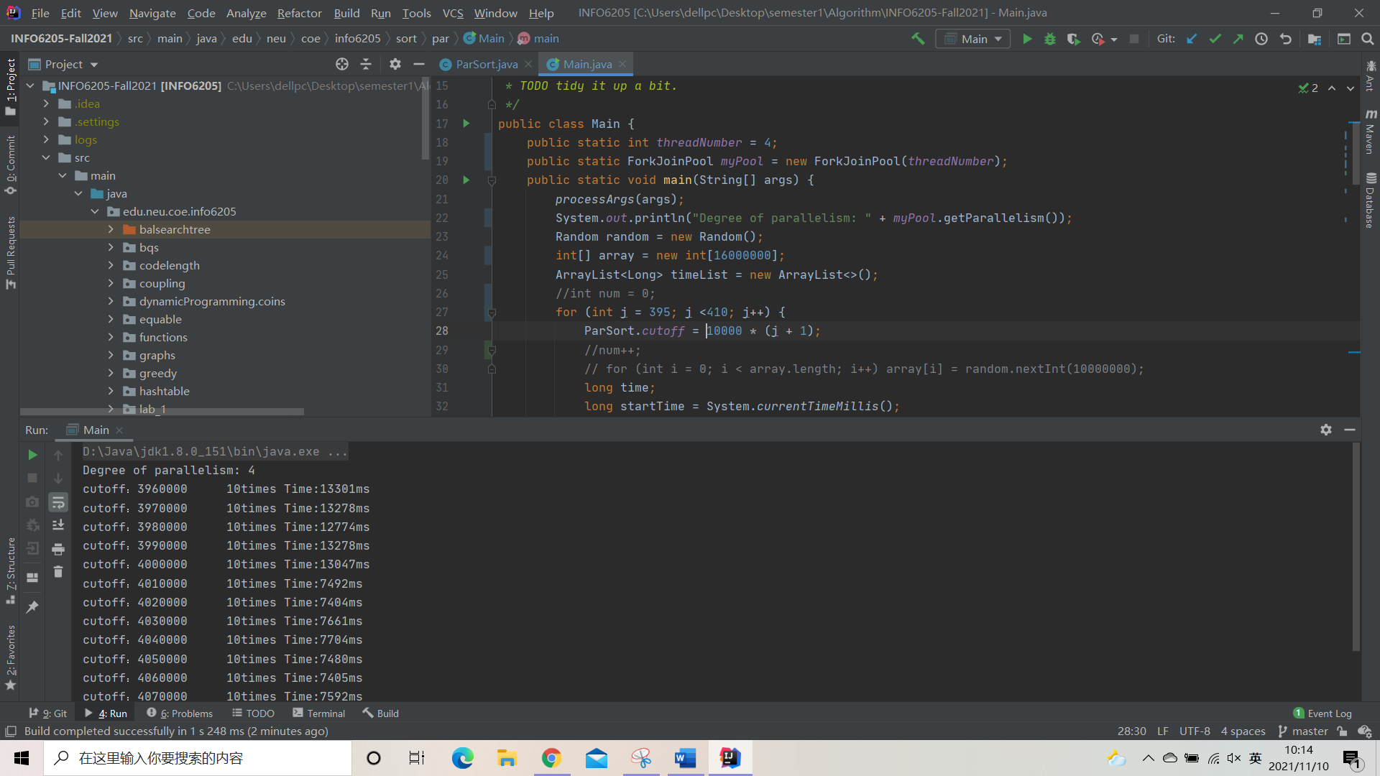

**Output text:**

**Degree of parallelism: 4**

**cutoff：3960000 10times Time:13301ms**

**cutoff：3970000 10times Time:13278ms**

**cutoff：3980000 10times Time:12774ms**

**cutoff：3990000 10times Time:13278ms**

**cutoff：4000000 10times Time:13047ms**

**cutoff：4010000 10times Time:7492ms**

**cutoff：4020000 10times Time:7404ms**

**cutoff：4030000 10times Time:7661ms**

**cutoff：4040000 10times Time:7704ms**

**cutoff：4050000 10times Time:7480ms**

**cutoff：4060000 10times Time:7405ms**

**cutoff：4070000 10times Time:7592ms**

We could find that in this case, time drops a lot after the cutoff is more than 4,000,000.

At which time, $\frac{arrays.length}{threadNumber}= \frac{16000000}{4}=4,000,000$.

**(6)Output when** **threadNumber = 4 and array’s length = 32,000,000**

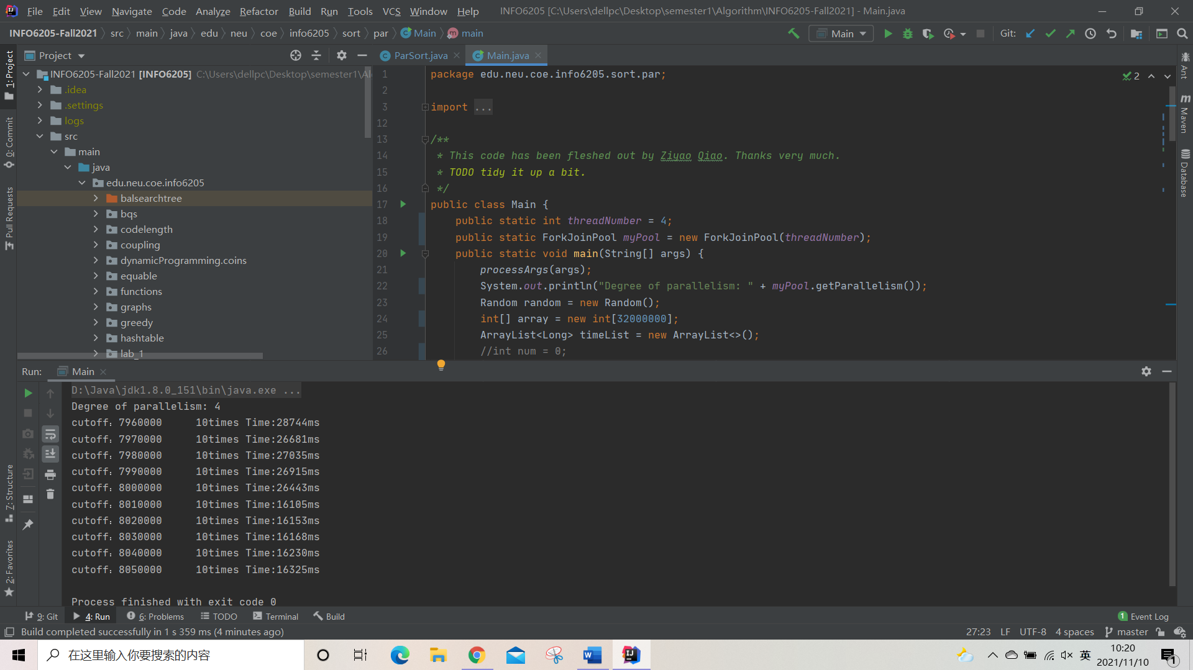

**Output text:**

**Degree of parallelism: 4**

**cutoff：7960000 10times Time:28744ms**

**cutoff：7970000 10times Time:26681ms**

**cutoff：7980000 10times Time:27035ms**

**cutoff：7990000 10times Time:26915ms**

**cutoff：8000000 10times Time:26443ms**

**cutoff：8010000 10times Time:16105ms**

**cutoff：8020000 10times Time:16153ms**

**cutoff：8030000 10times Time:16168ms**

**cutoff：8040000 10times Time:16230ms**

**cutoff：8050000 10times Time:16325ms**

We could find that in this case, time drops a lot after the cutoff is more than 8,000,000.

At which time, $\frac{arrays.length}{threadNumber}= \frac{32000000}{4}=8,000,000$.

It seems that when threadNumber = 4 and array’s length = 64,000,000, my computer didn’t work well so I stopped the simulation.

The simulation between the array’s length and the best cutoff number when the number of threads is unchangeable is showed below.



**It shows that the 10times Time of the best cutoff is proportional to the array’s length, and the proportionality factor is around 4, which is the same as the unchangeable thread number.**

**Combined with the analysis of the previous point ②, we could make a conclusion that the function between the number of threads, the array’s length and the best cutoff number is as the following:**

$$the best cutoff number= \frac{arrays.length}{threadNumber}$$

**We could make tests for our conclusion.**

* 1. **Keep the $\frac{arrays.length}{threadNumber}$ unchangeable, search for the best cutoff number.**

**(1)** **Output when threadNumber = 2 and array’s length = 1,000,000**

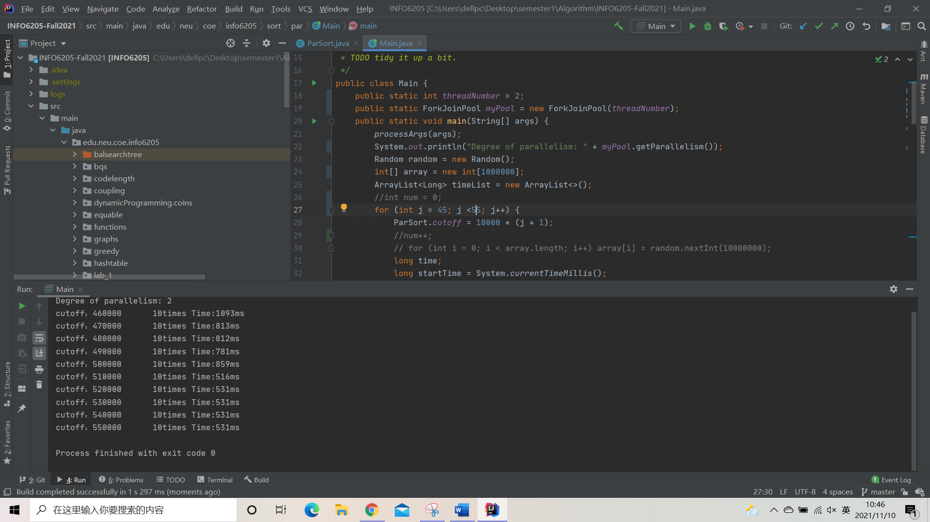

**Output text:**

**Degree of parallelism: 2**

**cutoff：460000 10times Time:1093ms**

**cutoff：470000 10times Time:813ms**

**cutoff：480000 10times Time:812ms**

**cutoff：490000 10times Time:781ms**

**cutoff：500000 10times Time:859ms**

**cutoff：510000 10times Time:516ms**

**cutoff：520000 10times Time:531ms**

**cutoff：530000 10times Time:531ms**

**cutoff：540000 10times Time:531ms**

**cutoff：550000 10times Time:531ms**

**(2)Output when threadNumber = 4 and array’s length = 2,000,000**





**Output text:**

**Degree of parallelism: 4**

**cutoff：450000 10times Time:1375ms**

**cutoff：460000 10times Time:1327ms**

**cutoff：470000 10times Time:1359ms**

**cutoff：480000 10times Time:1344ms**

**cutoff：490000 10times Time:1265ms**

**cutoff：500000 10times Time:1328ms**

**cutoff：510000 10times Time:812ms**

**cutoff：520000 10times Time:813ms**

**cutoff：530000 10times Time:828ms**

**cutoff：540000 10times Time:812ms**

**cutoff：550000 10times Time:828ms**

**(3) Output when threadNumber = 8 and array’s length = 4,000,000**

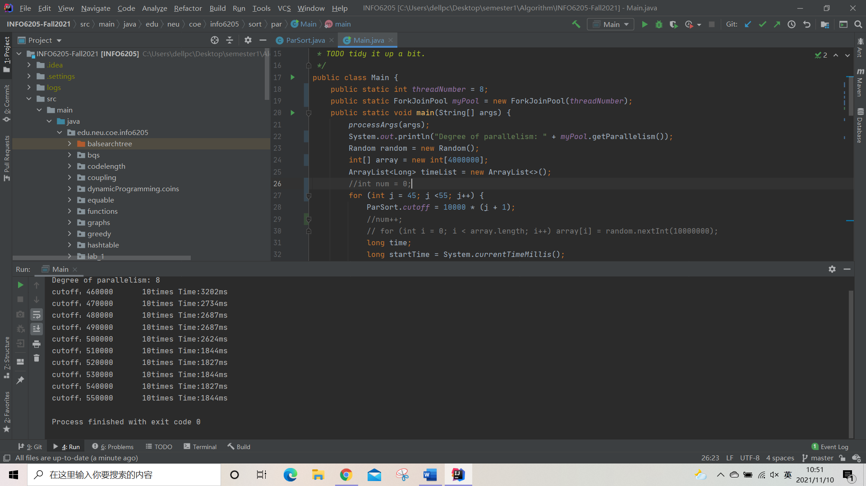

**Output text:**

**Degree of parallelism: 8**

**cutoff：460000 10times Time:3202ms**

**cutoff：470000 10times Time:2734ms**

**cutoff：480000 10times Time:2687ms**

**cutoff：490000 10times Time:2687ms**

**cutoff：500000 10times Time:2624ms**

**cutoff：510000 10times Time:1844ms**

**cutoff：520000 10times Time:1827ms**

**cutoff：530000 10times Time:1844ms**

**cutoff：540000 10times Time:1827ms**

**cutoff：550000 10times Time:1844ms**

**(4) Output when threadNumber = 16 and array’s length = 8,000,000**

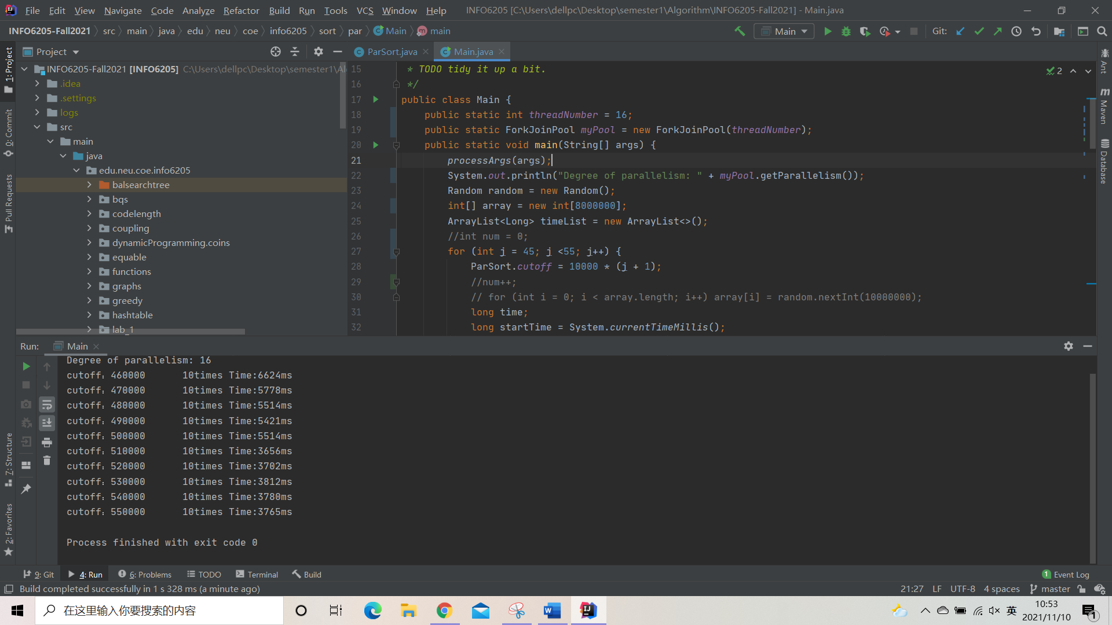

**Output text:**

**Degree of parallelism: 16**

**cutoff：460000 10times Time:6624ms**

**cutoff：470000 10times Time:5778ms**

**cutoff：480000 10times Time:5514ms**

**cutoff：490000 10times Time:5421ms**

**cutoff：500000 10times Time:5514ms**

**cutoff：510000 10times Time:3656ms**

**cutoff：520000 10times Time:3702ms**

**cutoff：530000 10times Time:3812ms**

**cutoff：540000 10times Time:3780ms**

**cutoff：550000 10times Time:3765ms**

**(5) Output when threadNumber = 32 and array’s length = 16,000,000**

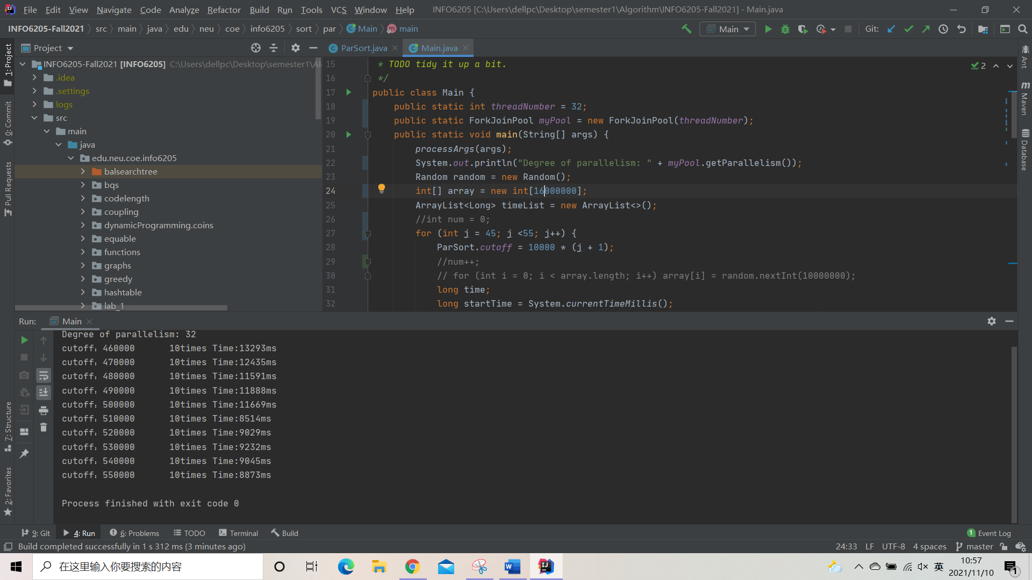

**Output text:**

**Degree of parallelism: 32**

**cutoff：460000 10times Time:13293ms**

**cutoff：470000 10times Time:12435ms**

**cutoff：480000 10times Time:11591ms**

**cutoff：490000 10times Time:11888ms**

**cutoff：500000 10times Time:11669ms**

**cutoff：510000 10times Time:8514ms**

**cutoff：520000 10times Time:9029ms**

**cutoff：530000 10times Time:9232ms**

**cutoff：540000 10times Time:9045ms**

**cutoff：550000 10times Time:8873ms**

**We could see in the tests, if the $\frac{arrays.length}{threadNumber}$ is unchangeable, the best cutoff number always occurs at the number of 500,000, which is equals to the number of $\frac{arrays.length}{threadNumber}$. The function seems right.**